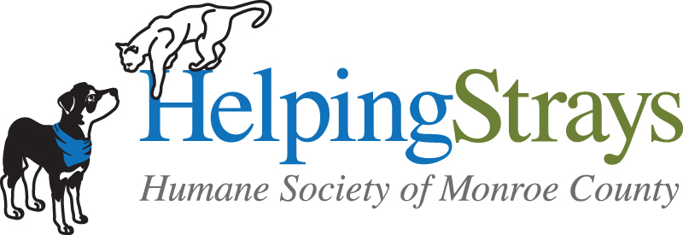

Humane Society of Monroe County, IL

VOLUNTEER RELEASE FORM

By signing below, I accept a position as Volunteer for the Humane Society of Monroe County, IL (Helping Strays), herein after referred to as “Helping Strays”, upon the following terms, conditions, and understandings:

Terms & Conditions

My services to Helping Strays are provided strictly in a voluntary capacity as a Volunteer, and without any express or implied promise of salary, compensation or other payment of any kind whatsoever.

My services are furnished without any employment-type benefits, including employment insurance programs, worker’s compensation accrual in any form, vacations or sick time.

I will accept the guidance and decisions of the volunteer coordinator. I will stay within the bounds of volunteer responsibility.

I will familiarize myself and comply with Helping Strays policies, procedures, and protocols. Failure to do so may result in my immediate termination as a volunteer. In particular, I fully understand that Helping Strays expects high standards of moral and ethical treatment of the animals in its care. I will adhere strictly to these standards in my capacity as a Volunteer.

I agree to be present for my assigned shifts and to carry out duties promptly and reliably.

Release

I understand that the handling of animals and other Volunteer activities on behalf of Helping Strays may place me in a hazardous situation and could result in injury to me or my personal property. On behalf of myself, and my heirs, personal representatives and assigns, I hereby release, discharge, indemnify and hold harmless Helping Strays and its directors, officers, employees and agents from any and all claims, causes of action and demands of any nature, whether known or unknown, including costs and attorney’s fees incurred by Helping Strays in connection with the same, based on damages or injuries arising out of or in connection with my Volunteer activities on behalf of Helping Strays.

Photographs: public relations are an important part of a Volunteer’s activities on behalf of Helping Strays. On behalf of myself, my heirs, personal representatives, and executors, I hereby authorize Helping Strays to use any photographs of me in its possession for public relations purposes. Helping Strays will have the right to use all photographs that I submit to Helping Strays for marketing materials or in any other way Helping Strays sees fit.

Notice to pregnant Volunteers – possible risk of exposure to toxoplasmosis: I understand that there is a small but medically serious risk of exposing my unborn fetus to toxoplasmosis. I understand that this organism may pose a risk of harm to my unborn fetus. I further understand that it is solely my responsibility to monitor my status regarding pregnancy. I also understand that the organism toxoplasmosis exists widely in the modern environment apart from the feline population, and can be contracted in ways other than from a cat.

I have read this agreement carefully and fully understand its contents. I am aware that this is a waiver and release of liability, and an enforceable contract between me and Helping Strays. I of my own free will acknowledge this.

Date Signature of Volunteer Signature of Helping Strays Representative

Parent or Legal Guardian
(for volunteers 17 years and younger)

As a parent or legal guardian of the above-name volunteer, I hereby give consent for my child or ward, as the case maybe, to become a Volunteer for Helping Strays as described in the above Volunteer Agreement and, by the signature below, join in and agree to be bound by the terms and conditions of the Release on this Agreement. I understand that each volunteer 17 years and younger must be accompanied by a parent/guardian or authorized adult at all times.

Date Signature of Volunteer Signature of Helping Strays Representative

The Mission of the Humane Society of Monroe County (Helping Strays) is to make a difference in the lives of animals. We are a charitable organization promoting responsible pet ownership. Helping Strays is dedicated to creating a world where our relationship with animals is guided by compassion. Our goal is to help prevent animal cruelty and place abandoned, adoptable, health pets in loving new homes. We cherish our animal companions for their unconditional affection and acceptance. We seek a truly humane society in which animals are respected for their intrinsic value, and where the human-animal bond is strong.

